**STRUKTUR DATA DAN ALGORITME**

**LAPORAN REVISI INDIVIDU PROJEK AKHIR SEMESTER 2**

**Dosen Pengampu: Dr. Elly Matul Imah, M. Kom.**

**Fadhillah Qolbi Annisa , M. Sc.**

**Instansi : Universitas Negeri Surabaya**

**Nama: Dian Ayu Fauziah**

**NIM : 22031554011**

**Kelas : Sains Data B 2022**

1. **Tugas Revisi**
2. Membuat Button Back pada tampilan akhir
3. Menambahkan Gambar pada halaman yang berisi algoritma dan juga halaman terakhir
4. Menambahkan gambar pada button di halaman yang berisi algoritma
5. **Tampilan Sebelum Revisi**

**2.1**

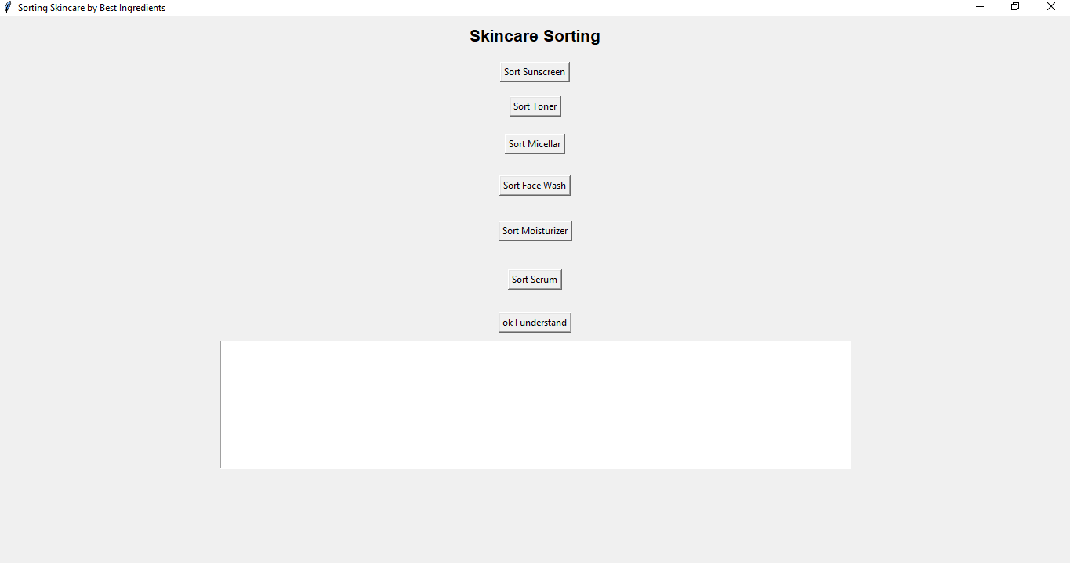

**Gambar 2.1** adalah tampilan sebelum direvisi, tidak ada gambar pada background tidak ada gambar pada button

**2.2**

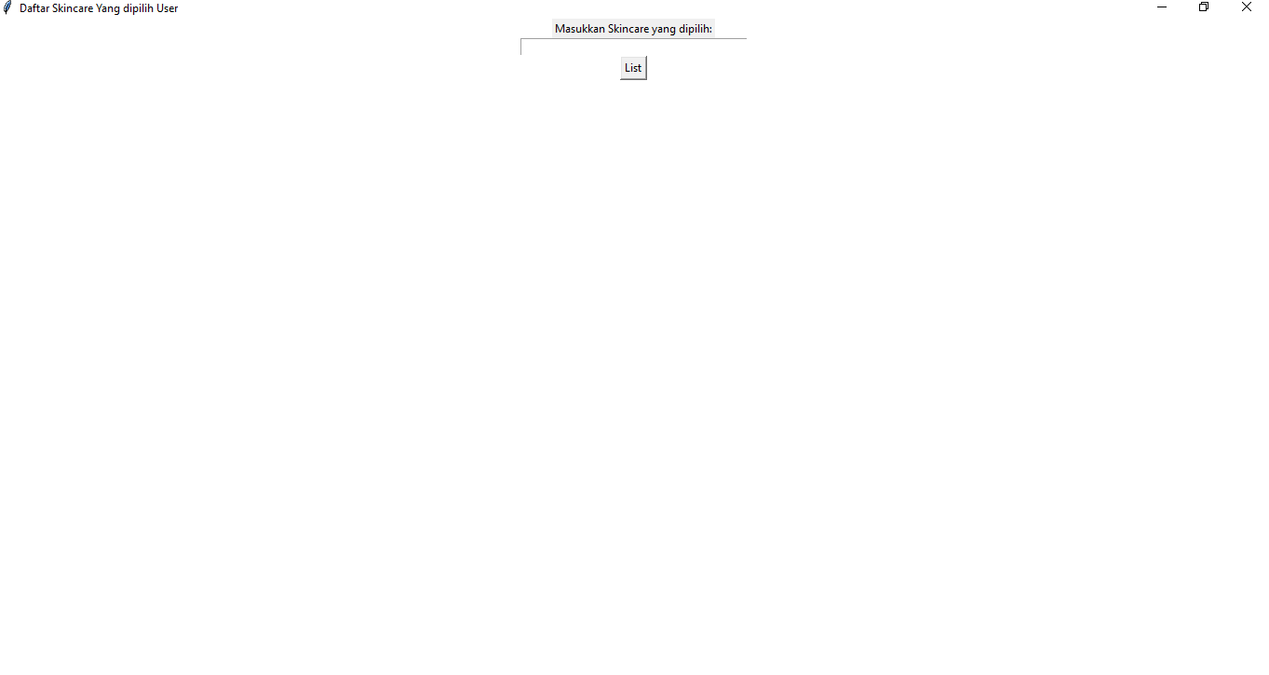

**Gambar 2.2** adalah tampilan sebelum direvisi, tidak ada gambar pada background dan juga tidak ada button back

1. **Tampilan setelah revisi**

**3.1**

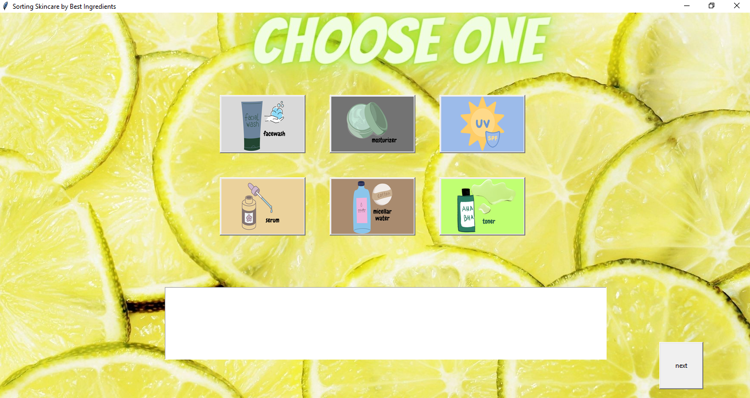

**Gambar 3.1** adalah tampilan yang sudah direvisi, sudah ditambahkan gambar untuk background dan juga sudah ditambahkan gambar pada masing-masing button

**3.2**

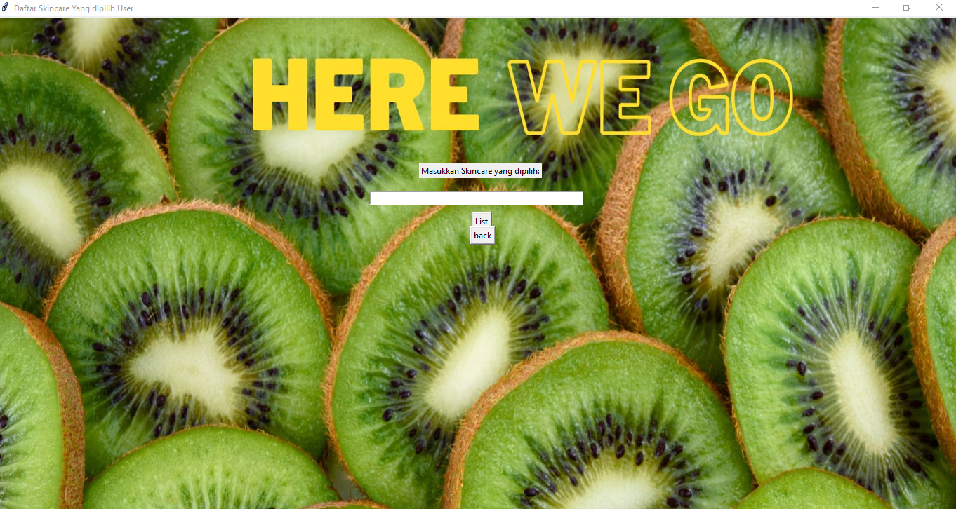

**Gambar 3.3** adalah tampilan setelah direvisi, sudah ditambahkan gambar untuk background dan juga menambahkan button back

1. **Listing Code**

from tkinter import *

from tkinter.ttk import Combobox

import tkinter as tk

from PIL import Image, ImageTk

from tkinter import messagebox

from tkinter.messagebox import showinfo

from tkinter import Tk, Label, Button, Entry, StringVar

class SkincareSorter():

    def __init__(self, root):

        self.root = root

        self.root.title("Sorting Skincare by Best Ingredients")

        self.root.geometry("400x300")

        image_path = "E:/DataC_250423/user/wishlist skincare/project skincare/sale (1).jpg"

        image_path2 = "E:/DataC_250423/user/wishlist skincare/project skincare/sale (2).jpg"

        image_path3 = "E:/DataC_250423/user/wishlist skincare/project skincare/sale (3).jpg"

        image_path4 = "E:/DataC_250423/user/wishlist skincare/project skincare/sale (4).jpg"

        image_path5 = "E:/DataC_250423/user/wishlist skincare/project skincare/sale (5).jpg"

        image_path6 = "E:/DataC_250423/user/wishlist skincare/project skincare/sale (6).jpg"

        image_path7 = "E:/DataC_250423/user/wishlist skincare/project skincare/sale (7).jpg"

        # Membaca gambar menggunakan PIL

        image = Image.open(image_path)

        image2 = Image.open(image_path2)

        image3 = Image.open(image_path3)

        image4 = Image.open(image_path4)

        image5 = Image.open(image_path5)

        image6 = Image.open(image_path6)

        image7 = Image.open(image_path7)

        # Mengubah ukuran gambar sesuai kebutuhan

        image = image.resize((1500, 750), Image.ANTIALIAS)

        image2 = image2.resize((150, 100), Image.ANTIALIAS)

        image3 = image3.resize((150, 100), Image.ANTIALIAS)

        image4 = image4.resize((150, 100), Image.ANTIALIAS)

        image5 = image5.resize((150, 100), Image.ANTIALIAS)

        image6 = image6.resize((150, 100), Image.ANTIALIAS)

        image7 = image7.resize((150, 100), Image.ANTIALIAS)

        # Membuat objek ImageTk dari gambar

        image_tk = ImageTk.PhotoImage(image)

        image_tk2 = ImageTk.PhotoImage(image2)

        image_tk3 = ImageTk.PhotoImage(image3)

        image_tk4 = ImageTk.PhotoImage(image4)

        image_tk5 = ImageTk.PhotoImage(image5)

        image_tk6 = ImageTk.PhotoImage(image6)

        image_tk7 = ImageTk.PhotoImage(image7)

        # Membuat label untuk menampilkan gambar

        image_label = Label(root, image=image_tk)

        image_label.pack()

        image_label2 = Label(root, image=image_tk2)

        image_label2.pack()

        image_label3 = Label(root, image=image_tk3)

        image_label3.pack()

        image_label4 = Label(root, image=image_tk4)

        image_label4.pack()

        image_label5 = Label(root, image=image_tk5)

        image_label5.pack()

        image_label6 = Label(root, image=image_tk6)

        image_label6.pack()

        image_label7 = Label(root, image=image_tk7)

        image_label7.pack()

        # Menampilkan gambar

        image_label.image = image_tk

        image_label2.image = image_tk2

        image_label3.image = image_tk3

        image_label4.image = image_tk4

        image_label5.image = image_tk5

        image_label6.image = image_tk6

        image_label7.image = image_tk7

        self.sort_button_ss = Button(root, width=150, height=100, text="", command=self.sorted_ss_normal)

        self.sort_button_ss.config(image=image_tk2, compound="top")

        self.sort_button_ss.place(x=800, y=150)

        self.sort_button_toner = Button(root, width=150, height=100, text="", command=self.sorted_toner_normal)

        self.sort_button_toner.config(image=image_tk3, compound="top")

        self.sort_button_toner.place(x=800, y=300)

        self.sort_button_micellar = Button(root, width=150, height=100, text="", command=self.sorted_micellar_normal)

        self.sort_button_micellar.config(image=image_tk4, compound="top")

        self.sort_button_micellar.place(x=600, y=300)

        self.sort_button_fwash = Button(root, width=150, height=100, text="", command=self.sorted_Fwash_normal)

        self.sort_button_fwash.config(image=image_tk5, compound="top")

        self.sort_button_fwash.place(x=400, y=150)

        self.sort_button_moist = Button(root, width=150, height=100, text="", command=self.sorted_moist_normal)

        self.sort_button_moist.config(image=image_tk6, compound="top")

        self.sort_button_moist.place(x=600, y=150)

        self.sort_button_serum = Button(root, width=150, height=100, text="", command=self.sorted_serum_normal)

        self.sort_button_serum.config(image=image_tk7, compound="top")

        self.sort_button_serum.place(x=400, y=300)

        self.sort_button_submit = Button(root, width=10, height=5, text="next", command=self.open_user)

        self.sort_button_submit.place(x=1200, y=600)

        # self.result_text = Text(root, width=100, height=10)

        # self.result_text.place(x=150, y=500)

        self.result_text = Text(root, width=100, height=8)

        self.result_text.place(x=300, y=500)

    def selection_sort_skincare(self, skincare_list):

        for i in range(len(skincare_list)):

            max_index = i

            for j in range(i + 1, len(skincare_list)): #mencari indeks dengan daftar kandungan_terbaik yag terpanjang

                if len(skincare_list[j]['kandungan_terbaik']) > len(skincare_list[max_index]['kandungan_terbaik']): #memeriksa

                    max_index = j

            skincare_list[i], skincare_list[max_index] = skincare_list[max_index], skincare_list[i]

    def display_sorted_skincare(self, skincare_data):

        sorted_skincare = ""  #menyimpan produk skincare yang telah

        for skincare in skincare_data:

            sorted_skincare += skincare['nama'] + ' - ' + ', '.join(skincare['kandungan_terbaik']) + '\n'

        self.result_text.delete(1.0, END)

        self.result_text.insert(END, sorted_skincare)

    def sorted_ss_normal(self):

        sunscreen_normal_data = [

            {'nama': 'Whitelab UV Shield Tank Sunscreen Gel SPF 50++', 'kandungan_terbaik': ['Niacinamide', 'Hyaluronic Acid']},

            {'nama': 'Erha21 Perfect Shield for Normal & Dry SPF #)', 'kandungan_terbaik': [' Vit E', 'NIacinamide', 'Aloe Vera']},

            {'nama': 'Wardah UV Shield Essential Sunscreen Gel SPF 30', 'kandungan_terbaik': ['Aloe Vera']},

        ]

        self.selection_sort_skincare(sunscreen_normal_data)

        self.display_sorted_skincare(sunscreen_normal_data)

    def sorted_micellar_normal(self):

        micellar_normal_data = [

            {'nama': 'Corine de Farme Purity Micellar Water', 'kandungan_terbaik': ['Citric Acid']},

            {'nama': 'Wardah Cleansing Micellar Water', 'kandungan_terbaik': [' Allantoin', 'Glycerin']},

            {'nama': 'Nivea Micellar Skin Breathe Biru', 'kandungan_terbaik': ['Citric Acid', 'Glycerin', 'Sodium Chloride']},

        ]

        self.selection_sort_skincare(micellar_normal_data)

        self.display_sorted_skincare(micellar_normal_data)

    def sorted_toner_normal(self):

        toner_normal_data = [

            {'nama': 'Pyunnkang Yul Essence Toner', 'kandungan_terbaik': ['Carbomer']},

            {'nama': 'COSRX AHA BHA Clarifying Treatment Toner ', 'kandungan_terbaik': [' Allantoin', 'Glycerin', 'Carbomer']},

            {'nama': 'The Body Shop Vitamin E Hydrating Toner', 'kandungan_terbaik': ['Glycerin']},

        ]

        self.selection_sort_skincare(toner_normal_data)

        self.display_sorted_skincare(toner_normal_data)

    def sorted_Fwash_normal(self):

        fwash_normal_data = [

            {'nama': 'Cethapil Gentle Skin Cleanser', 'kandungan_terbaik': ['Niacinamide', 'Pro-Vita B5', 'Glycerin']},

            {'nama': 'Neutrogena Hydro Boost Hydrating Cleansing Gel ', 'kandungan_terbaik': ['Glycerin', 'Hyaluronic Acid']},

            {'nama': 'Olay Foaming Face Wash For Sensitive Skin', 'kandungan_terbaik': ['Glycerin', 'Niacinamide', 'Lauric Acid', 'Aloe Vera']},

        ]

        self.selection_sort_skincare(fwash_normal_data)

        self.display_sorted_skincare(fwash_normal_data)

    def sorted_serum_normal(self):

        serum_normal_data = [

            {'nama': 'Somebymi Snail Truecica Miracle Repair', 'kandungan_terbaik': ['Niacinamide', 'Allantoin']},

            {'nama': 'Nacific Phyto Niacin ', 'kandungan_terbaik': ['Niacinamide', 'Hyaluronic Acid', 'Lemon Extrak']},

            {'nama': 'Elsheskin Smoothing Serum for acne skin', 'kandungan_terbaik': ['Glycerin', 'Centella Asiatica', 'Salysilic Acid', 'Alkcohol']},

        ]

        self.selection_sort_skincare(serum_normal_data)

        self.display_sorted_skincare(serum_normal_data)

    def sorted_moist_normal(self):

        moist_normal_data = [

            {'nama': 'SKINTIFIC 5x Ceramide Barrier Repair Moisturizer Gel',

             'kandungan_terbaik': ['Ceramide', 'Hyaluronic Acid', 'Centella Asiatica']},

            {'nama': 'Joylab Moisture Bomb Pudding Gel Creme ', 'kandungan_terbaik': ['Glycerin', 'Niacinamide']},

            {'nama': 'NPure Day Cream Centella', 'kandungan_terbaik': ['Centella Asiatica', 'Salycilic Acid']},

        ]

        self.selection_sort_skincare(moist_normal_data)

        self.display_sorted_skincare(moist_normal_data)

    def open_user(self):

        self.root.destroy()

        new_root = Tk()

        new_root.title("Next Window")

        new_root.geometry("500x500")

        next_gui = choosen(new_root)

        new_root.mainloop()

class choosen:

    daftar_mhs = []

    def __init__(self, master):

        self.master = master

        master.title("Daftar Skincare Yang dipilih User")

        master.geometry("350x250")

        master['background'] = 'yellow'

        # Menambahkan gambar

        img_path = "E:/DataC_250423/user/wishlist skincare/project skincare/sale.jpg"

        image = Image.open(img_path)

        image = image.resize((1500, 1000))  # Mengubah ukuran gambar sesuai kebutuhan

        photo = ImageTk.PhotoImage(image)

        self.image_label = Label(master, image=photo)

        self.image_label.image = photo  # Menyimpan referensi gambar agar tidak dihapus oleh garbage collector

        self.image_label.place(x=0, y=0)  # Menempatkan gambar di posisi (0, 0)

        self.label = Label(master, text="Masukkan Skincare yang dipilih:")

        self.label.place(x=600, y=210)  # Menempatkan label di posisi (20, 150)

        self.nama = StringVar()

        self.field_nama = Entry(master, textvariable=self.nama, width=50)

        self.field_nama.place(x=530, y=250)  # Menempatkan input field di posisi (20, 180)

        self.button = Button(master, text="List", command=self.daftar)

        self.button.place(x=675, y=280)

        self.button2 = Button(master, text="back", command=self.go_back)

        self.button2.place(x=673, y=300)

        # self.button2 = Button(master, text="back", command=self.go_back)

        # self.button2.place(x=675, y=290) # Menempatkan tombol di posisi (20, 210)

    def daftar(self):

        mhs = self.nama.get()

        choosen.daftar_mhs.append(mhs)

        showinfo(message="{} berhasil ditambahkan kedalam troly!\n\nDaftar Skincare menjadi:\n{}".format(mhs, choosen.daftar_mhs))

        self.nama.set("")

    def go_back(self):

        self.master.destroy()

root = Tk()

skincare_sorter = SkincareSorter(root)

root.mainloop()